update

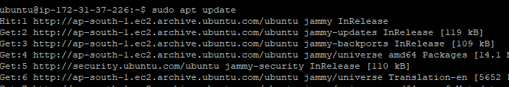

Install

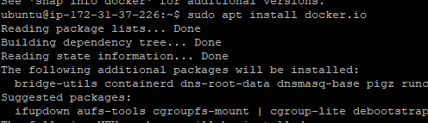

Checking docker version

C:\Users\dac\Pictures\3.PNG

Checking status of docker

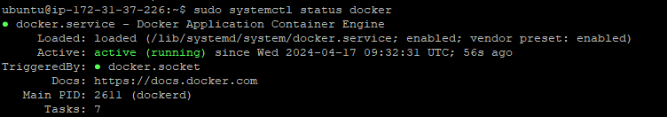

List the container images

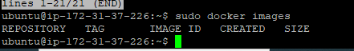

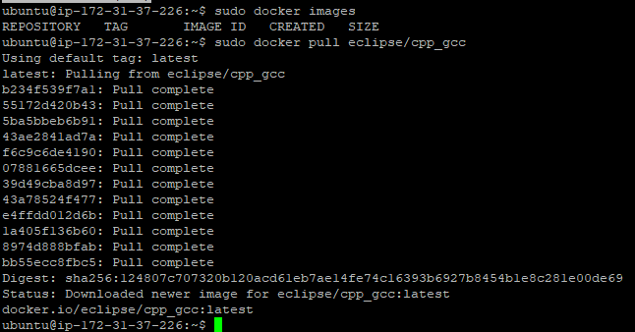

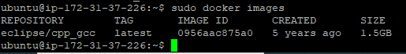

Pulling nginx

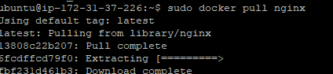

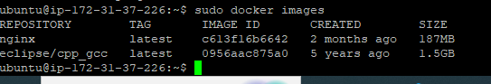

Downloaded the cpp images from dockerhub & runned it

